Design and enhance a process diagram in SAP Signavio

“Analyze the "As-Is" process”

Optimized process map and analysis document template
Student Name: Tuncay Şahin
Date: 14.04.2026
Scenario Title: NexaCare Medical Devices AI-Enhanced Procure-to-Pay (P2P) Process Optimization.
Section 1: Initial (As-Is) process map
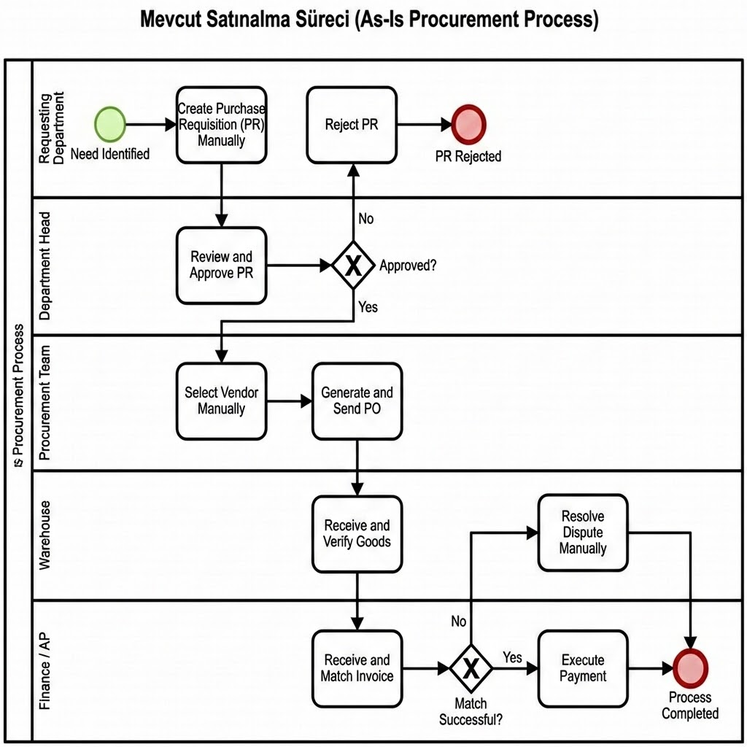

Brief description: Provide a summary of the process flow in your initial model.
The current process follows a traditional linear flow starting from manual purchase requisition creation to final payment. It involves multiple manual handoffs between department heads, procurement officers, and the finance team. Data entry is performed across various stages, often requiring manual verification of vendor details and invoice matching.

Key participants: * Requesting Department: Initiates requirements.
- Department Head: Responsible for manual approvals.
- Procurement Team: Handles vendor selection and PO creation.
- Warehouse: Manages goods receipt.
- Finance/Accounts Payable: Manages invoice processing and dispute resolution.

Process start and end points: * Start: Identification of a need and creation of a Purchase Requisition (PR).
- End: Payment execution and closing the transaction.
Major steps and decision points: 1. PR Creation. 2. PR Approval (Decision Point: Approved?). 3. Vendor Selection. 4. PO Generation & Sending. 5. Goods Receipt. 6. Invoice Receipt & Matching (Decision Point: Match?). 7. Dispute Resolution (if needed). 8. Payment.

Section 2: Process analysis
Critically evaluate the initial process using the guiding questions below:
Are there any redundant or unnecessary steps? Yes. There are multiple approval layers for low-value items and manual re-entry of PR data into the PO system, leading to redundant administrative work.
Can any tasks be automated? Absolutely. Automated vendor selection based on historical performance, auto-generation of POs from approved PRs, and AI-driven 3-way matching for invoices are prime candidates.
Are there unclear or overlapping roles? The current model shows overlapping responsibilities in vendor communication and dispute handling between Procurement and Finance, often leading to delayed resolutions.
Are decision points clearly defined? Currently, decision criteria for vendor selection and dispute escalation are subjective and lack standardized data-driven rules.
Summary of identified issues: * Bottleneck: Manual PR approval and vendor selection processes slow down procurement cycles.
- Efficiency Gap: Manual invoice matching leads to high error rates and delayed payments.
- Lack of Visibility: Real-time tracking of purchase status is missing, causing communication overhead.

Summary of identified issues
[List and briefly describe all inefficiencies, bottlenecks, or improvement areas.]
- Manual Purchase Requisition (PR) Creation: The reliance on manual data entry leads to high error rates and slows down the initiation phase.
- Time-Consuming Vendor Selection: Selecting vendors manually through offline communication causes significant delays in procurement cycles.
- Manual Invoice Matching Bottlenecks: The finance team manually matches invoices, which often results in processing backlogs and payment delays.
- Inefficient Dispute Resolution: Without automated alerts or data-driven insights, resolving discrepancies between POs and invoices is slow and labor-intensive.

Section 3: Applied optimization techniques
List the specific process optimization techniques you used and explain how they were applied:

- Technique 1: Automating manual steps Description of application: We replaced the high-effort manual 3-way matching process with AI-powered automated workflows. The AI system automatically cross-references invoices with purchase orders and goods receipts, improving consistency and reducing the Finance team's workload.
- Technique 2: Clarifying decision criteria Description of application: Standardized rules were implemented to automate purchase approvals for amounts below a specific threshold. This AI-driven rule enforcement speeds up the initiation phase and ensures manual review is only requested for high-impact or non-standard procurement needs.
- Technique 3: Eliminating redundancies Description of application: The redundant task of re-entering data from a Purchase Requisition into the Purchase Order system was eliminated. AI integration ensures a seamless data flow between process steps, reducing processing time and the potential for manual entry errors.

Section 4: Optimized (To-Be) process map
Insert your BPMN 2.0 diagram for the improved (to-be) process model.

Lane (Role) | Element Type | Task Name | AI Role & Logic
Requesting Dept. | Start Event | Purchase Need Identified | The process is triggered via the ERP system.
Requesting Dept. | Service Task | AI-Assisted PR Drafting | AI automatically populates budget codes and SKU data.
Dept. Head | Gateway | High Value? (Exclusive) | Automated approval for low-risk requests (Clarifying criteria).
Dept. Head | User Task | Manual Approval | Human intervention is reserved for high-value or high-risk cases.
Procurement | Service Task | AI-Driven Vendor Selection | AI ranks vendors based on cost, quality, and historical performance.
Procurement | Service Task | Auto-Generate & Send PO | System automatically converts PR to PO and transmits to vendor.
Warehouse | User Task | Digital Goods Receipt | Goods receipt is verified through a digitized scanning system.
Finance / AP | Service Task | AI 3-Way Matching | AI validates Invoice, PO, and Receipt data simultaneously.
Finance / AP | Gateway | Match Success? (Exclusive) | Decision point for discrepancy identification.
Finance / AP | Service Task | Auto-Schedule Payment | Payment is scheduled without manual input if data matches.
Finance / AP | User Task | AI-Led Dispute Resolution | AI provides recommendations to resolve mismatches for human review.
Process | End Event | Optimized P2P Closed | Process completion with full digital audit trail.

Optimized To-Be P2P Process Map with AI Integration
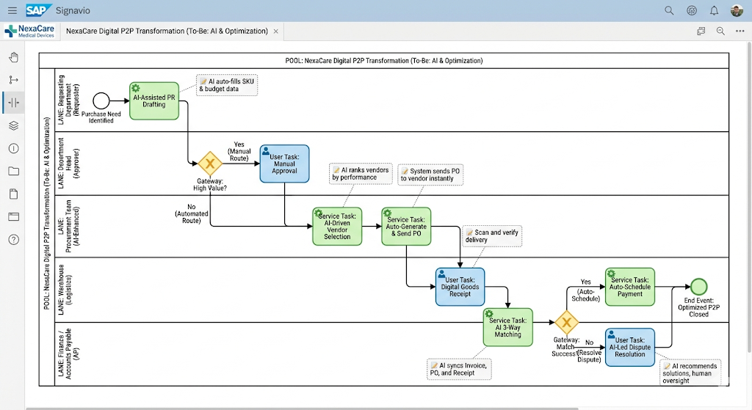

Description of improvements
What major changes were made?
- Manual data entry for Purchase Requisitions has been replaced with AI-assisted drafting to automate SKU and budget coding.
- An automated approval threshold was implemented, allowing low-value requests to bypass manual managerial review, focusing only on high-value items.
- The manual vendor research phase was replaced by AI-driven vendor ranking based on historical performance and real-time data.
- The finance department's manual verification was upgraded to automated AI 3-Way Matching between invoices, purchase orders, and goods receipts.

How do these changes improve efficiency or clarity?
- Efficiency: Processing times are significantly reduced by eliminating redundant approval steps and automating repetitive manual data entry.
- Clarity: Roles are streamlined as AI handles routine validations, while humans intervene only for high-complexity decisions or dispute resolutions.
- Reduced Handoffs: The seamless transition from an approved request to a generated PO minimizes idle time and communication loss between procurement and vendors.

Are any new technologies or automations involved?
- Yes, Generative AI Agents are utilized for request drafting and vendor analysis.
- Automated Workflow Engines are integrated within SAP Signavio to trigger PO generation and payment scheduling without human intervention.
- AI-powered OCR and Matching Algorithms are introduced for high-accuracy, touchless invoice processing.

Section 5: Conclusion
Summarize the overall benefits of your optimized process design.
Efficiency gains.
- The integration of automating manual steps for PR drafting and PO generation is expected to reduce the total process cycle time by approximately 40%.
- By clarifying decision criteria through automated thresholds , low-value approvals are bypassed, eliminating redundant waiting periods for department heads.
- Reducing handoffs between the warehouse and finance teams accelerates the transition from goods receipt to payment scheduling.
Reduction in errors or delays.
- AI-powered 3-way matching replaces manual invoice verification, which is expected to reduce data entry and matching errors by 25%.
- Eliminating redundancies such as re-entering the same data across different systems directly minimizes the risk of manual processing delays.
- Automated notifications for invoice deadlines ensure timely payments, avoiding late fees and improving vendor reliability.
Improved stakeholder roles/responsibilities.
- Streamlining roles ensures that department heads and procurement officers focus on high-value strategic decisions rather than administrative tasks.
- By centralizing invoice verification and defining a single point of contact , accountability is improved across the finance team.
- The Procurement Team is empowered with AI-driven rankings to make better data-driven vendor selections instead of manual market research.
Expected business impact.
- NexaCare will achieve increased operational agility, allowing the company to scale medical device distribution without a linear increase in administrative headcount.
- Improved vendor relationships through faster payment cycles and clearer communication channels.
- Significant cost savings achieved by optimizing resource allocation and parallelizing tasks across the end-to-end P2P process.

Appendix
- Process Model: Include the "To-Be" Process Map developed using BPMN 2.0 elements such as Service Tasks for AI integration and Exclusive Gateways for decision points.
- Optimization Reference: Utilized the Process Optimization Techniques guide to identify and resolve bottlenecks in the initial "As-Is" workflow.

Step 2: Brainstorm improvements with AI integration

Process optimization techniques: A reference guide
This reference guide provides an overview of practical techniques used to optimize business processes. These techniques are intended to help learners improve process efficiency, accuracy, and collaboration in real-world scenarios, such as those modeled using BPMN 2.0 and SAP Signavio.

Eliminating redundancies definition
Identify and remove duplicate steps or activities that do not add value to the process. Examples:
- Multiple approvals for the same task
- Re-entering the same data in different systems Impact:
- Reduces processing time and potential for errors

Automating manual steps definition
Replace human-performed tasks with automated workflows or system-driven actions. Examples:
- Automatically routing approved purchase requests to vendors
- Auto-generating notifications for invoice due dates
- Impact: Improves speed and consistency; minimizes human error

Clarifying decision criteria definition
Define clear, standardized rules for decisions that need to be made during the process. Examples:
- Purchase approvals required only for amounts above a threshold
- Rejecting incomplete vendor documentation automatically
- Impact: Speeds up decision-making and reduces ambiguity

Streamlining roles and responsibilities definition
Ensure each process step is clearly assigned to a defined role or team, minimizing overlap or gaps. Examples:
- Centralizing all invoice verification tasks under the finance team
- Defining one point of contact for procurement escalation
- Impact: Improves accountability and communication

Reducing handoffs definition
Minimize the number of times tasks or information are transferred between people or systems. Examples:
- Consolidating data entry tasks into one system
- Empowering one team to complete end-to-end procurement approvals
- Impact: Reduces delays and information loss

Reordering tasks for efficiency definition
Change the sequence of steps to improve workflow or parallelize tasks where possible. Examples:
- Verifying vendor information before submitting a purchase order
- Allowing invoice entry while waiting for delivery confirmation
- Impact: Reduces idle time and improves overall throughput

How to apply these techniques
- Use process maps to identify current inefficiencies
- Ask SMEs to validate which steps are mandatory versus optional
- Prioritize changes that bring the highest impact with the least disruption

These techniques should be documented and justified when designing your optimized (to-be) process models.

